## Change Budget

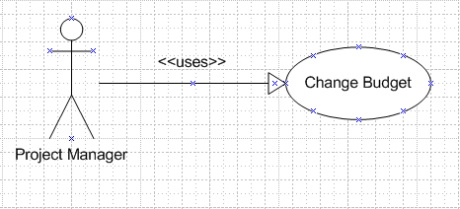

Figure xx Change Budget Use Case model

Use Case scenario:

Table x Change Budget scenario

|  |  |  |
| --- | --- | --- |
| User Case ID | UC_P.5 | |
| Name | **Change Budget Use Case** | |
| Goal | This function allows project manager to manage a project’s budget | |
| Actors | **Project Manager** | |
| Pre-conditions | Logged user that is a project manager | |
| Post-conditions | None | |
| Main Flow | 1. Choose tab “Cost”    3. Select button “OK” on the commit window. | 2. Fill the budget value then select button “Change Budget” |
|  |  | |
| Open Issues | N/A | |

## Add Expense

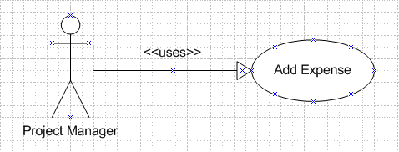

Figure xx Add Expense Use Case model

Use Case scenario:

Table x Add Expense scenario

|  |  |  |
| --- | --- | --- |
| User Case ID | UC_P.6 | |
| Name | **Add Expense Use Case** | |
| Goal | This function allows project manager to add a project’s expense | |
| Actors | **Project Manager** | |
| Pre-conditions | Logged user that is a project manager | |
| Post-conditions | None | |
| Main Flow | 1. Choose tab “Cost”  3. Fill in the expense’s information then select button “Submit” | 2. Select “Add new Expense” |
|  |  | |
| Open Issues | N/A | |

## Edit Expense

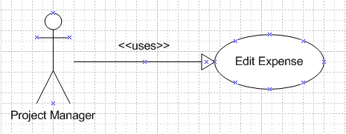

Figure xx Edit Expense Use Case model

Use Case scenario:

Table x Edit Expense scenario

|  |  |  |
| --- | --- | --- |
| User Case ID | UC_P.7 | |
| Name | **Edit Expense Use Case** | |
| Goal | This function allows project manager to edit a project’s expense | |
| Actors | **Project Manager** | |
| Pre-conditions | Logged user that is a project manager | |
| Post-conditions | None | |
| Main Flow | 1. Choose tab “Cost”  3. Fill in the expense’s information then select button “Save Change” | 2. Select the expense want to edit |
|  |  | |
| Open Issues | N/A | |

## Delete Expense

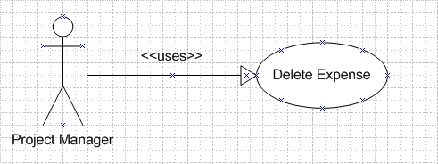

Figure xx Delete Expense Use Case model

Use Case scenario:

Table x Delete Expense scenario

|  |  |  |
| --- | --- | --- |
| User Case ID | UC_P.8 | |
| Name | **Delete Expense Use Case** | |
| Goal | This function allows project manager to delete a project’s expense | |
| Actors | **Project Manager** | |
| Pre-conditions | Logged user that is a project manager | |
| Post-conditions | None | |
| Main Flow | 1. Choose tab “Cost”    3. Select button “Delete” | 2. Select the checkbox at the begin of the expenses’ row you want to delete |
|  |  | |
| Open Issues | N/A | |

## Delete Risk, Issue

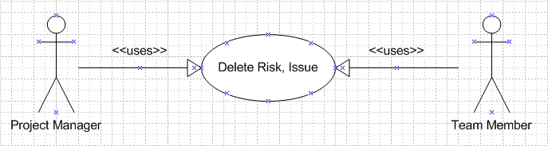

Figure xx Delete Risk, Issue Use Case model

Use Case scenario:

Table x Delete Risk, Issue scenario

|  |  |  |
| --- | --- | --- |
| User Case ID | UC_P.11 | |
| Name | **Delete Risk, Issue Use Case** | |
| Goal | This function allows project manager and team member to delete a project’s risk, issue | |
| Actors | **Project Manager, Team member** | |
| Pre-conditions | Logged user that is a project manager or team member | |
| Post-conditions | None | |
| Main Flow | 1. Choose tab “Risk, Issue”    3. Select button “Delete” | 2. Select the checkbox at the begin of the row you want to delete |
|  |  | |
| Open Issues | N/A | |

## Delete Change Request

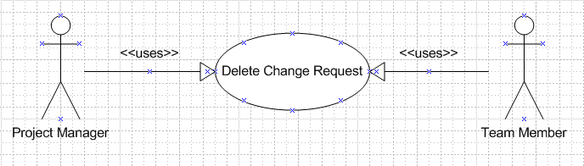

Figure xx Delete Change Request Use Case model

Use Case scenario:

Table x Delete Change Request scenario

|  |  |  |
| --- | --- | --- |
| User Case ID | UC_P.14 | |
| Name | **Delete Change Request Use Case** | |
| Goal | This function allows project manager and team member to delete a project’s change request | |
| Actors | **Project Manager, Team member** | |
| Pre-conditions | Logged user that is a project manager or team member | |
| Post-conditions | None | |
| Main Flow | 1. Choose tab “Change Request”    3. Select button “Delete” | 2. Select the checkbox at the begin of the row you want to delete |
|  |  | |
| Open Issues | N/A | |

## Delete Product

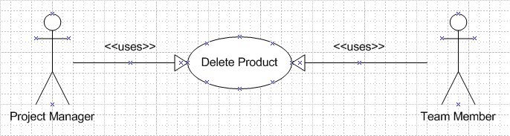

Figure xx Delete Product Use Case model

Use Case scenario:

Table x Delete Product scenario

|  |  |  |
| --- | --- | --- |
| User Case ID | UC_P.17 | |
| Name | **Delete Product Use Case** | |
| Goal | This function allows project manager and team member to delete a project’s product | |
| Actors | **Project Manager, Team member** | |
| Pre-conditions | Logged user that is a project manager or team member | |
| Post-conditions | None | |
| Main Flow | 1. Choose tab “Product”    3. Select button “Delete” | 2. Select the checkbox at the begin of the row you want to delete |
|  |  | |
| Open Issues | N/A | |

## Delete Stage

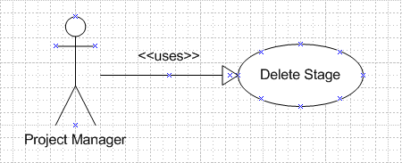

Figure xx Delete Stage Use Case model

Use Case scenario:

Table x Delete Stage scenario

|  |  |  |
| --- | --- | --- |
| User Case ID | UC_P.20 | |
| Name | **Delete Stage Use Case** | |
| Goal | This function allows project manager to delete a project’s stage | |
| Actors | **Project Manager** | |
| Pre-conditions | Logged user that is a project manager | |
| Post-conditions | None | |
| Main Flow | 1. Choose tab “Work Order”    3. Select button “Delete” | 2. Select the checkbox at the begin of the stages’ row you want to delete |
|  |  | |
| Open Issues | N/A | |

## Delete Deliverable

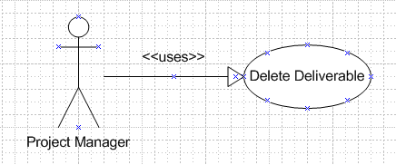

Figure xx Delete Deliverable Use Case model

Use Case scenario:

Table x Delete Deliverable scenario

|  |  |  |
| --- | --- | --- |
| User Case ID | UC_P.23 | |
| Name | **Delete Deliverable Use Case** | |
| Goal | This function allows project manager to delete a project’s deliverable | |
| Actors | **Project Manager** | |
| Pre-conditions | Logged user that is a project manager | |
| Post-conditions | None | |
| Main Flow | 1. Choose tab “Work Order”    3. Select button “Delete” | 2. Select the checkbox at the begin of the deliverables’ row you want to delete |
|  |  | |
| Open Issues | N/A | |